Summary - Theory Quiz 4 (Modules 6 & 7)
Question 1: Which protocol implements the Media Access Control in Ethernet?
A. CSMA/CD B. CSAM/CD C. CSMA/CA D. AXMA/CD E. CSMA/CV
Question 2: Two devices are directly connected by an Ethernet link. Both devices can communicate to each other without collisions. The duplex setting of their link is:
A. two-way duplex B. synchronous duplex C. half duplex
D. full duplex E. The duplex setting does not impact collisions
Question3 : Consider the following Switch and its MAC Address Table shown in the Figure. PC-A sends a frame to PC-B. How does the Switch know on which port to send the frame?
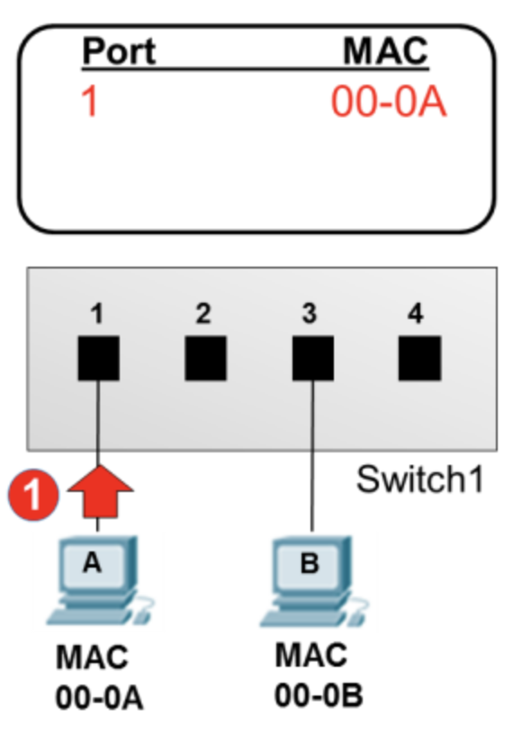
A. The Switch does not know where to send the frame and drops it until it can learn the correct port.
B. The MAC Address table is populated with the MAC Address-to-Port mapping information and the switch uses this information to select the outgoing port.
C. The MAC Address Table must be statically configured with the correct information.
D. The Switch floods the frame on all ports except the one connected to PCA.
E. The switch broadcasts an ARP request for the destination device. When the destination device responds with the ARP reply, the switch learns on which port the destination port is connected.
Question 4: Select all that is true about the Data Link layer:
A. Detects errors in transmission. B. Correct errors in transmission.
C. Determines when a device can transmit on the physical media (MAC)
D. Enables upper layers to be media independent.
E. Dictates a network's physical topology
Question5 : Which topology scenarios may result in multiple MAC addresses being assigned to one Switch Port in the MAC Address Table? (select two)
A. This impossible and it means that there has been a MAC Address Table error.
B. A router is connected to a Switch port.
C. An Ethernet hub is connected to a Switch port.
D. Two switches are connected together.
E. Multiple devices are connected to the same physical switch port.
Question 2: Which of the following addresses does a device use when deciding to accept a frame?
A. source MAC address B. source IP address C. destination MAC address
D. destination IP address E. source Ethernet address
Question 4: For the following network diagram, how many Destination Ethernet Addresses are required to send a message from PC0 to PC1?
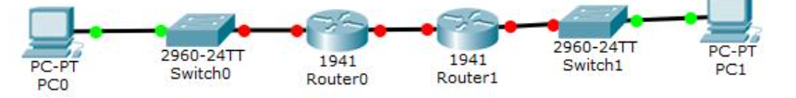
A. 1 B. 2 C. 3 D. 4 E. 5
Question 5: What is the format of a Broadcast MAC Address?
A. BR-OA-DC-AS-T0-00 B. 00-00-00-00-00-00 C. FF-FF-FF-FF-FF-FF D. 23-af-56-b4-9c-4e
Question 4：What information is stored in the Switch's MAC Address Table? (Select two)
Current Date and Time
Switch Port Number
Attached Device's IP Address
Attached Device's MAC Address
Attached Device Type (i.e. PC, VoIP, Video)

